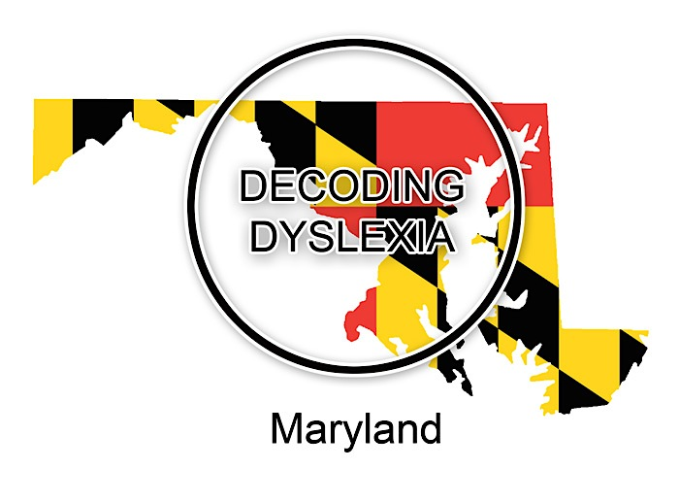
Decoding Dyslexia
Southern Maryland
Parent Support & DD-MD Business Meeting
1 in 5 children struggle to read and have a language learning difference like dyslexia. If your child or student struggles to read, write & spell, please join DD-MD to share resources and learn more about how to support students in the classroom.

Date: Monday, November 17, 2014 (3rd Monday)
Time: 7:00-9:00pm (Parent Support 7-8pm & DD-MD Business Meeting 8-9pm)
Place: Patuxent Presbyterian Church
2341 Kingston Creek Road, California, Md 20619
Contact: Laura Schultz at DecodingDyslexiaMD@gmail.com
Twitter: @dyslexiasomd
Website: http://www.decodingdyslexiamd.weebly.com

